Dear [new member],
Hello, and welcome to the Michigan Digital Preservation Network! We are delighted to have you join this collaborative initiative dedicated to keeping Michigan’s unique cultural legacy safe and secure for the long-term future. Your membership in the MDPN demonstrates your commitment to be the best steward possible for the collections you hold. The MDPN provides affordable and easy-to-use digital preservation services to cultural memory institutions across Michigan. To make this possible, the MDPN is both a digital preservation service and a community of practice. We provide the infrastructure for preserving digital materials and bring together people in Michigan to learn, work, and innovate as a community.
By being part of the MDPN, you are also now part of a larger global community! The MDPN engages with the National Digital Stewardship Alliance, the LOCKSS community, and the annual iPres conference. Being an MDPN member opens doors to a supportive community of digital preservation practitioners from Amsterdam to New Zealand.
This New Member Onboarding Packet – including a helpful checklist that follows this letter – will help to orient you to the MDPN and address any questions you might have. If you have any questions or concerns during the Onboarding Process – or at any time during your membership – please reach out to me, members of the Advisory Committee, or any MDPN community member. Thank you, truly, for being part of this community. We could not do this work without you!
Sincerely,
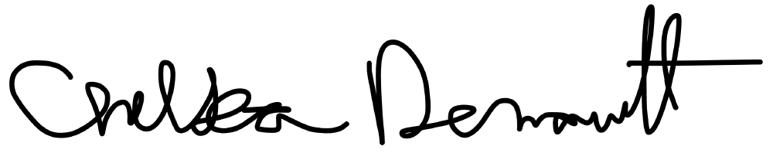
Chelsea Denault, Ph.D.
Michigan Digital Preservation Network Coordinator
Midwest Collaborative for Library Services

Table of Contents
Table of Contents 2
New Member Checklist 2
Governance 3
Committees 3
Community 4
MDPN Members 4
Affiliated Communities 4
Conferences, listservs and workshops 5
MDPN Guide 6
Communications 7
Slack 7
Technical Documentation 8
Workflow Diagram 8
Support Requests 8
Github 9
Member Documentation 9
Node Hosts Documentation 9
Additional Documentation 9
Additional Services 10

New Member Checklist
Membership agreement sent/signed
Contacts established (main contact, technical contact, financial contact)
Institutional code determined (subject to approval)
Membership invoice received/paid
Sign up for Communication Channels
Listservs
Slack
Google Calendar of committee meetings
Identified and assigned committee representatives (see Governance Section)
Using MDPN
Download and configure DART
Share IP address/receive Staging Server credentials
Schedule Training (in-person or via Zoom)
Select collections to preserve
Transfer first collection during training
Receive confirmation email of successful deposit

Governance
Useful Information:
Governance Page: https://mipres.org/index.php/governance/
MDPN Governance Policy and Appendices: https://drive.google.com/file/d/1Nnj5SbLaYCBEuX_3aSaQOGzsAucrdUwG/view?usp=sharing
MDPN Code of Conduct: http://mipres.org/index.php/about/code-of-conduct/ and Reporting Form: https://forms.gle/kM9wepe4dSXGfdem8

The MDPN is led by an Advisory Committee elected by its members. The Committee is responsible for informing the strategic vision of the MDPN, developing a transparent approach to financial management, and assisting with overall management, coordination, communication, and reporting efforts of the MDPN. It represents the interests of the member community.

The MDPN also has a Coordinator who is responsible for representing the MDPN in Michigan and the broader digital preservation community, managing memberships and other fees, forwarding engagement and education efforts, organizing meetings of the Advisory Committee and the three standing Committees, maintaining the MDPN’s documentation, and implementing decisions made by the Advisory Committee. The Coordinator reports to the MCLS IT Director, and works with the Advisory Committee to inform the strategic vision for the MDPN and assist with overall management, coordination, communication, and reporting efforts of the MDPN. The Coordinator assists in implementing actions decided by the Advisory Committee.

As the fiscal agent and organizational home of the MDPN, the Midwest Collaborative for Library Services (MCLS) retains responsibility for MDPN operations. The Library of Michigan (LM) owns the Memorandum of Understanding that established the MDPN, and provides funding for its operations through federal LSTA funds. Both LM and MCLS have joint responsibility for approving actions that have a financial impact on the MDPN.

Committees
The MDPN provides opportunities for all members to volunteer their time with the Network through three standing Committees:

Elections and Nominating Committee: responsible for the solicitation of candidates, the presentation of the slate to the Advisory Committee, and the oversight and execution of the election.
Membership Committee: addresses the needs and concerns of current members in order to promote improvement in member relations and aid in long-term retention, as well as planning, developing, and evaluating strategies for deepening engagement across the MDPN’s membership
Technical Committee: reviews and maintains technical specifications and documentation, and makes recommendations on issues relating to hardware and software.

Upon joining the MDPN, new members will be asked to participate in one of the above committees. Committee participants must be individual members or employed at organizations that are members in good standing of the MDPN.

Community
Useful Information:
Members Page: https://mipres.org/index.php/members/
MDPN Resources Page: https://mipres.org/index.php/resources/

There are multiple layers to the MDPN community. There is the community of fellow MDPN members, but MDPN membership also opens the door to membership in and engagement with the broader international digital preservation community. Below you’ll find an outline of the many ways you can open the doors to digital preservation!

MDPN Members
The MDPN Member Community is open to any cultural memory or collecting institution in Michigan that manages digital content. Membership fees are tiered based on a member’s annual operating budget and can be found in Appendix 3 of the Governance Policy. Anchor Members are those that make significant financial or in-kind contributions to the MDPN.

Anchor Members:
Detroit Institute of Arts
Library of Michigan
Michigan State University
University of Michigan, Ann Arbor
Wayne State University
Western Michigan University

MDPN Members:
Arab American National Museum
Capital Area District Libraries
Comstock Township Library
Eastern Michigan University
Hillsdale College
Kalamazoo College
Kalamazoo Valley Museum
Northern Michigan University
Sloan Museum of Discovery
Traverse Area District Library
A map of current members can be found on the front page of the MDPN’s website, MIpres.org.

Affiliated Communities
Private LOCKSS Network (PLN) Community
As a user of the LOCKSS software, the MDPN is part of the PLN community, a group of international users whose preservation services are also built on the LOCKSS software. PLNs use LOCKSS for a variety of different purposes, from journal harvesting to preserving research data and scholarly outputs. PLN members gather quarterly as part of the Cross-PLN Technical Working Group and monthly as part of The LOCKSS Council, a body that includes representatives from the PLNs and the Global LOCKSS Network to advocate for continued improvements to the LOCKSS software and for support for the LOCKSS Program.

National Digital Stewardship Alliance (NDSA)
The NDSA is a consortium of 278 partnering organizations, including universities, professional associations, businesses, government agencies, and nonprofit organizations, all committed to the long-term preservation of digital information. Members collaborate via working groups that are open to anyone to preserve access to our digital heritage. NDSA is hosted by the Digital Library Federation. The MDPN is a member of NDSA and MDPN Coordinator Chelsea Denault currently serves on the NDSA Coordinating Committee.

Digital Preservation Services Collaborative (DPSC)
The DPSC is a group of collaborating organizations united in the commitment to digital preservation that explores how we can better communicate with each other and assist members of the wider community. In 2017, this group drafted a Digital Preservation Declaration of Shared Values that seeks to capture the mission of our shared work and the values that govern that work. Revisions continued from the initial publication, resulting in the January 2024 publication of Version 4 in English. The MDPN is a partner in the DPSC.

iPres
iPRES is an international community of digital preservation researchers and practitioners who gather annually at the iPres Conference. Whether in-person, virtual, or hybrid, iPRES activities aim to bring together all parts of the global digital preservation community to exchange ideas, research, and good practice as well as to create spaces that foster mutual support.

Conferences, listservs and workshops
The Michigan Digital Preservation Network encourages members to be engaged with the larger digital preservation community through the attendance of statewide, national, and international conferences. The MDPN may have travel funds available to members who present about their experience using MDPN. Reach out to the MDPN Coordinator for more information.

Conferences:

Statewide:
Mid-Michigan Digital Practitioners (MMDP)

National:
DLF Forum
NDSA DigiPres
Best Practices Exchange
code4lib
International:
iPres
INSPRD

Email Lists
Email lists are a useful way to stay informed with happenings in the digital preservation community, including workshops and trainings, new research and publications, and conferences. They are also great places to ask questions of the larger community.

MMDP - an email list managed by the Mid-Michigan Digital Practitioners (MMDP), typically used to share information about events, conferences, and other opportunities for engagement in Michigan. Not very active, but used to share announcements about annual MMDP meetings.
NDSA-all - an email list managed by NDSA, often used to announce NDSA events, publications, working group or interest group meetings, and other happenings in the digital preservation community.
Digital-Preservation - an email list managed by JISC, a UK-based organization that supports digital collections research. This list is very often used to ask questions re: best practices or to troubleshoot issues.

Workshops/Training:
These organizations host digital preservation workshops and trainings often, though not always for free, on a variety of digital preservation topics.

Northeast Document Conservation Center (NEDCC)
Digital Preservation Coalition (DPC)
Digital Preservation Outreach and Education Network (DPOE-N)
National Digital Stewardship Alliance (NDSA)
Preserving (Digital) Objects With Restricted Resources (POWRR)

MDPN Guide Program
The MDPN Guide Program connects new MDPN members with longstanding members to help navigate the MDPN community and onboarding process. While the MDPN is an open community of practice that all members should feel comfortable drawing upon for expertise and experience, we also understand that joining a new community can seem intimidating. This is not a “mentorship” program, but rather an additional resource to draw upon as new members find their stride in the MDPN.
There is no formal guide program; new members and their guides can choose their own meeting or check-in schedule and format that meets their needs and capacity. We do suggest an initial introductory meeting between guides and new members to open lines of communication and address any outstanding questions. Beyond this, guides and new members can meet monthly (or more frequently, especially at the beginning of the onboarding process) or can communicate on a more “as necessary” basis whenever the new member needs information.
Members who are willing to serve as guides share their contact information with the MDPN Coordinator, who then reaches out to the group as new guides are requested. To request a guide, contact the MDPN Coordinator.

Communications

Slack
To request access to the MDPN Slack, use the following referral link: https://join.slack.com/t/michigandigit-dsr5703/shared_invite/zt-3eq87tv35-bs0Mnny~VfiWcG9xH9uquw
The MDPN uses Slack for fun and informal communications between members, and sharing general information about the community. All members are expected to abide by the MDPN Code of Conduct when using the MDPN Slack
- MDPN Slack Channels:
  - #advisory-committee: to share information between members of the Advisory Committee
  - #conferences: to share information (i.e. registration, CfPs, volunteer opportunities, etc.) about relevant conferences
  - #digi-pets: to inspire joy and delight by sharing photos of the wide range of MDPN pets and acknowledge that they are all good.
  - #elections: to share information between members of the Elections and Nominating Committee
  - #fun: to share digital preservation or digital collections related humor (GIFs, jokes, etc.)
  - #general: to share information that is broadly relevant to everyone who is a member of the MDPN Slack Community
  - #kudos-korner: to recognize and acknowledge members who do kind things for other members and in the broader cultural memory community in Michigan
  - #membership: to share information between members of the Membership Committee
  - #technical: to share information between members of the Technical Committee

Technical Documentation
Useful Information:
Technology Page: https://mipres.org/index.php/technology/
Monitor Dashboard: link forthcoming
MDPN Github: https://github.com/MiDPN
Public Documentation: https://midpn.github.io/public-documentation/

The MDPN technical workflow has three separate parts built on three tools: transfer (DART), processing (staging server/processing script), and preservation storage (LOCKSS). Members are most responsible for the “Transfer” area of the workflow. MDPN staff and volunteers manage the “Processing” and “Preservation” areas on behalf of members.

Workflow Diagram
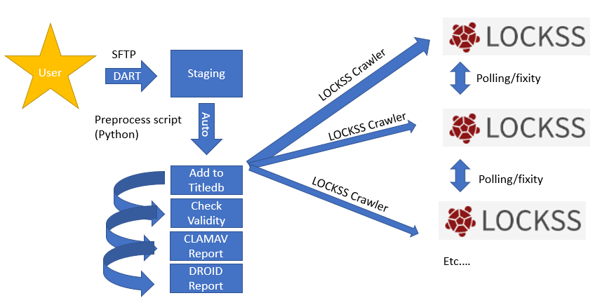

Support Requests
Support requests should be sent to support@mipres.org. Requests will generate a ticket on which MDPN staff and volunteers will follow up. DART issues can also be reported via the DART User Google Group: https://groups.google.com/a/aptrust.org/g/dart-users

Github
Github is an open platform for developers to collaborate and share project code and documentation. The MDPN Github is managed by MCLS IT Manager Sean Cwiek. Most MDPN Members will not need to create a Github account to use the Network.

If you want to edit or contribute to the MDPN’s Github, follow these steps:
Create a Github Account: https://docs.github.com/en/get-started/start-your-journey/creating-an-account-on-github If you are unfamiliar with Github and would like to learn more about how to navigate the platform and commonly used terms: https://www.freecodecamp.org/news/guide-to-git-github-for-beginners-and-experienced-devs/#terms

Members are expected to adhere to the MDPN Code of Conduct when using Github.

Member Documentation
Documentation for all MDPN members can be found on our Public Documentation site: https://midpn.github.io/public-documentation/
Note: While the public documentation is viewable by anyone, members will need to communicate their IP addresses and receive credentials from MDPN staff before the file transfer processes can be undertaken (see the New Member Checklist).

Node Hosts Documentation
The MDPN’s private documentation for node hosts requires login access via Github. Link forthcoming!

Additional Documentation
The documentation below is created and maintained by the respective tool/program owners and is provided here for MDPN Members’ reference only.
LOCKSS 2.0 System Manual: https://docs.lockss.org/projects/manual/en/latest/
LOCKSS Github: https://github.com/lockss
DART Documentation: https://aptrust.github.io/dart-docs/
DART Github: https://github.com/APTrust/dart

Additional Services
To help share knowledge and expertise from across the digital preservation field, the MDPN offers a range of consulting services at no or low cost to members. These services include, but are not limited to:
Benchmarking and Assessment
Services to help determine where your organization is at towards implementing a digital preservation strategy, where your organization is currently doing well and areas for future improvement.
Policy Planning and Writing
Guidance regarding policy writing and best practices research, building a policy formation team, drafting a policy, collecting and analyzing stakeholder feedback, and moving the policy through necessary approval processes.
Team Building and Advocacy
Facilitation for identifying key organizational stakeholders, assessing staff skill strengths and gaps, providing training and education on digital preservation topics, and making a compelling case for preservation funding and support.
Migration and Emulation
Advice for transferring unsupported or unrenderable file types from one format to another (i.e. migration) or setting up an environment to render files using obsolete operating systems and software (i.e emulation).

